Temasek Polytechnic

School of Informatics and IT

**Diploma in Information Technology (IT)**

Meeting Minutes

**Project Particulars**

|  |  |
| --- | --- |
| **Tutor** | Mr Qi Yutao |
| **Class** | P04 |
| **Project Title** | Delonix Regia Hotel Management System |

**Project Team’s Particulars**

|  |  |
| --- | --- |
| **Matric Number** | **Student Name** |
| **1701635C** | **Frederick Kang** |
| **1705035B** | **Pradhun Raj** |
| **1704762B** | **Haziq Asyraaf** |
| **1705922A** | **Max Ang Chong Wei** |

|  |  |  |
| --- | --- | --- |
| Date: | 29/11/2018 |  |
| Venue: | Meeting Room/Lab |  |
| Present: | Frederick Kang, Pradhun Raj,Haziq Asyraaf, Max Ang |  |
| Absent with apologies: | N/A |  |

Meeting started at 01:00 pm

The chairperson shared about Mr Wong,the hotel owner about the hotel. These followings points are the meeting minutes.

|  |  |  |
| --- | --- | --- |
| **1**    **2**  **3**  **4** | **Mr Wong has requested for these following functions in the system:**  **Room availability and booking module**  This will allow the reception staff to facilitate the bookings in hotel for the guest. This action fills the database with guest particulars and check the availability in the hotel.  **Staff management module**  This will keep track of the maintenance given for the staff. It consist of maintenance such as room, general to estate. This will act as checklist and auditing purposes.  **Report module**  This module generate reports based on the three report which is room status, all room listing and all guest listing. As such, it can be used to keep track of the guest history. It can also be used as statistics too  **User account login and signup module**  This module is regarding accounts. This includes creating an account, login into the website and lastly link the guest to the website. It is the basic functions for guest and users account to be created and log in to the website for basic use. | **Action By**  *Frederick is in charge of the room availability and booking module.*  *Max is in charge of staff management module.*  *Haziq is in charge of report module.*  *Raj is in charge of user account login and signup module* |

Meeting ended at 02:00 pm

Recorded by: Haziq

Vetted by: Raj

Temasek Polytechnic

School of Informatics and IT

**Diploma in Information Technology (IT)**

Software Requirement Specifications (SRS)

**Project Particulars**

|  |  |
| --- | --- |
| **Tutor** | Mr Qi Yutao |
| **Class** | P04 |
| **Project Title** | Hotel Management System |

**Project Team’s Particulars**

|  |  |
| --- | --- |
| **Matric Number** | **Student Name** |
| **1701635C** | **Frederick Kang** |
| **1705035B** | **Pradhun Raj** |
| **1704762B** | **Haziq Asyraaf** |
| **1705922A** | **Max Ang Chong Wei** |

Revision History

|  |  |  |  |
| --- | --- | --- | --- |
| **Date** | **Version** | **Description** | **Author** |
| 01/12/18 | 0.1 | Fill in the details, update on filling in | ALL |
| 15/12/18 | 0.2 | Update on requirements and constraints etc. | ALL |
| 3/1/19 | 1.0 | Check with the information on meetup | ALL |
| 4/1/19 | 1.2 | Final check on everything | Haziq,Raj |

**Table of Contents**

[**1.** **DISTRIBUTION OF WORKLOAD 4**](https://docs.google.com/document/d/108lvfV0U913wwQRnOAPH5mV7IRgnOUKeid6pq7tyuwY/edit#heading=h.26in1rg)

[**2.** **OVERVIEW OF REQUIREMENTS 4**](https://docs.google.com/document/d/108lvfV0U913wwQRnOAPH5mV7IRgnOUKeid6pq7tyuwY/edit#heading=h.30j0zll)

[*2.1* *System Functions 4*](https://docs.google.com/document/d/108lvfV0U913wwQRnOAPH5mV7IRgnOUKeid6pq7tyuwY/edit#heading=h.2et92p0)

[*2.2* *User Characteristics 4*](https://docs.google.com/document/d/108lvfV0U913wwQRnOAPH5mV7IRgnOUKeid6pq7tyuwY/edit#heading=h.tyjcwt)

[*2.3* *General Constraints 4*](https://docs.google.com/document/d/108lvfV0U913wwQRnOAPH5mV7IRgnOUKeid6pq7tyuwY/edit#heading=h.3dy6vkm)

[*2.4* *Functional Requirements 4*](https://docs.google.com/document/d/108lvfV0U913wwQRnOAPH5mV7IRgnOUKeid6pq7tyuwY/edit#heading=h.1t3h5sf)

[*2.5* *Data Requirements 4*](https://docs.google.com/document/d/108lvfV0U913wwQRnOAPH5mV7IRgnOUKeid6pq7tyuwY/edit#heading=h.4d34og8)

[*2.6* *User Interface Requirements 5*](https://docs.google.com/document/d/108lvfV0U913wwQRnOAPH5mV7IRgnOUKeid6pq7tyuwY/edit#heading=h.2s8eyo1)

[*2.7* *Assumptions 5*](https://docs.google.com/document/d/108lvfV0U913wwQRnOAPH5mV7IRgnOUKeid6pq7tyuwY/edit#heading=h.17dp8vu)

[**3** **REFERENCES 6**](https://docs.google.com/document/d/108lvfV0U913wwQRnOAPH5mV7IRgnOUKeid6pq7tyuwY/edit#heading=h.3rdcrjn)

# 1. DISTRIBUTION OF WORKLOAD

|  |  |
| --- | --- |
| **Requirement Gathering** | **Members** |
| 2.1.1 Room availability and booking module  2.5.1 Room availability and booking  2.6.1 Room availability and Booking Pages | Frederick Kang |
| 2.1.2 staff management module  2.5.2 staff management  2.6.2 staff management pages - | Max |
| TOC:Table of Content  2.1.3 Reporting/housekeeping module  2.3 General Constraints  2.4 Function Requirements  2.5.3 Report module  2.6.3 Report module Pages  2.7 Assumptions  3 References | Haziq |
| 2.1.4 User account login and signup module  2.4.4 User account login and signup module  2.5.4 User account login and signup  2.6.4 User account login and signup pages | Pradhun Raj |

# 2. OVERVIEW OF REQUIREMENT

## 2.1 System Functions

**2.1.1 Room availability and booking module.**

Should be able to accept data inputs such as First and Last name of the guest, The number of adult guests and children who will be staying in the room, contact details such as the phone number and email address of the guest, home and mailing address of the guest which are the street address, the block, the house number, as well as the postal code and country.

Should have payment Details for the guest, whether it is a credit card or cash payment and if it is a credit card payment it should have the credit card holder’s name, credit card number, and the expiration date for the credit card

Should be able to accept check in details for the guest, such check in date and time of the guest and desired checkout date and time for the guest, also additional remarks like if the guest would want a king sized bed or a queen sized bed, a smoking or non-smoking room, an indication of whether the guest is asking for a late check-in to his room.

**2.1.2 Staff management module**

The three duties are the general maintenance, room maintenance and estate maintenance.

General maintenance, is about preventative maintenance and it is to repairs to all areas of the hotel, including its exterior, heating and cooling systems, plumbing, electrical systems, floors, walls and furniture.

Room maintenance, is about maintaining the room in top shape.

Estate maintenance, is about maintenance for a the hotel facility. It involves a combination of technical and administrative actions carried out to retain an item, equipment, system, plant or machine in order to restore it to an acceptable working condition.

**2.1.3 Report module**

The three report are room status, all room listing and lastly all guest listing.

First report would be “Room status” that is able to list the status of all the rooms that shows whether its available,occupy or scheduled for cleaning.

Secondly would be “All Room listing” which list of all the rooms, these allows the report to show that name or number of occupants which also show whether its adult and children.

Thirdly is the “All Guest listing” which will list of all the guest of all the rooms, it should be able to list all the guest who is staying at these dates such as the starting of on the 1st of January of the year till the end of the year.

**2.1.4 User account login and signup module**

The three main functions of this module are signup, account login and linking the user account with the hotel room which is used by the user. The first function helps the guests to create an account in the hotel system. For this, the guest will have to provide their personal details like name, phone number, address, etc. The guest can use the account to use the hotel facilities including room booking. Once the account is created, the guest can login to their account. User account login functions helps the guest to login to the user account. For this function, the guest will have to enter their username and password. The third function links the user account with the hotel room. When the guest login to their account, the details of the guest and their room is displayed. The rooms and the user accounts are linked using the phone number or email id of the guest.

**2.2 User Characteristics**

End users who are the “Reception staff” at the front counter have full access to room availability and booking module and parts of the report of the reporting module.

Management level users full access to room availability and booking module, housekeeping and staff management module, and the reporting module.

Hotel Administrator who is in other words people like Mr Wang will have full access room availability and booking module, housekeeping and staff management module,reporting module, and the user account login and signup module.

## **2.3 General Constraints**

As requested by Mr wong , hotel owner. The system has only $70,000 budget which is finalised to spent.Software to be only installed in the single computer at the reception staff area.That single computer is an old pc pentium pc running on windows xp ( support package 2) 1GB RAM and 160GB HD and internet broadband wifi.

Secondly is the backup of the server of the system. Firstly, it cannot the shut down unless major renovation. It must be non peak hour after midnight ideally during 2-3am. Thirdly, it at least once a month falls on the first sunday.Lastly it must be kept for 5 years before it can be discarded. Only note to us being constraints are the peak hours for backup as the peak hours are around the check out time 11am - 12pm for the guest hotel.

The prototype and demonstration must be done by end of march. On the 31st of march ideally all of the key users are to be train and familiarity on the systems and 7th of april to be deployable and start live.

When all the requirements are met, the long term plans are firstly,room availability online function, because manual checking in the email system.Lastly, is the reporting modules of 5 reports to export to excel to have numeric numbers.

## 

## **2.4 Functional Requirements**

**2.4.1 Room availability and booking module**

For room availability and booking module details such as guest’s check-in details, payment details, room details should be editable and allow reception staff to change the details as and when they need to.

**2.4.2 Staff management module**

General maintenance, is about preventative maintenance and it is to repairs to all areas of the hotel, including its exterior, heating and cooling systems, plumbing, electrical systems, floors, walls and furniture.

General maintenance will have its own report saved on the system based on the all areas. It includes name, last date for maintenance, the company name that did the repair, remarks and lastly if it needs repair.

Room maintenance will have its own report saved on the system based on the all areas. It includes name of all the items in the room, last date for maintenance, the cleaner names that did the repair, remarks and lastly if it needs additional add up.

Estate maintenance will have its own report saved on the system based on the all areas. It includes name, last date for maintenance, the company name that did the repair, remarks and lastly if it needs repair.

**2.4.3 Report module**

The three report are room status, all room listing and lastly all guest listing.

Firstly would be “Room status” that is able to list the status of all the rooms that shows whether its available,occupy or scheduled for cleaning. The system must have a table that has the “id” of all the rooms , the “title” of each room and lastly a description that it editable to be change from available to occupy.

Secondly would be “All Room listing” which list of all the rooms, these allows the report to show that name or number of occupants which also show whether its adult and children. First it start with a table and the report must firstly have an “id” of which room is it referring. There will be a list of all the names in the “name” title, beside their names with be the “total numbers” of guest staying in that room and title description of children or adult.

Thirdly is the “All Guest listing” which will list of all the guest of all the rooms, it should be able to list all the guest who is staying at these dates such as the starting of on the 1st of January of the year till the end of the year. It starts with a table with two three titles , list “number” of the guest, secondly is the “name” of the guest and lastly is the “date”. The will be a setting that can be change in between the dates.

**2.4.4 User account login and signup module**

User signup function needs a few details of the guest such as name, address, phone number, age and a password to login. User login function only need the user name and their password. And the third function needs the phone number or email id of the user and the room details from the hotel system.

## **2.5 Data Requirements**

**2.5.1** Room availability and Booking

For room availability and booking module data such as the First and Last name of the guest, the number of adult guests and children who will be staying in the room, contact details such as the phone number and email address of the guest, home and mailing address of the guest which are the street address, the block, the house number, as well as the postal code and country. Payment Details for the guest, whether it is a credit card or cash payment and if it is a credit card payment it should have the credit card holder’s name, credit card number, and the expiration date for the credit card. Check in details for the guest, such check in date and time of the guest and desired checkout date and time for the guest, also additional data remarks like if the guest would want a king sized bed or a queen sized bed, a smoking or non-smoking room, an indication of whether the guest is asking for a late check-in to his room, all these information and details are the data required by the room availability and booking module

Room availability and Booking Table.

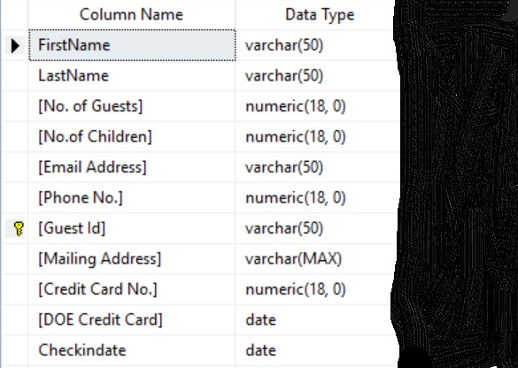

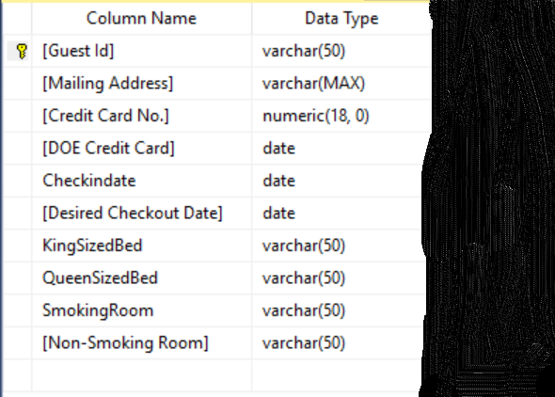

**2.5.2 Staff management module**

**Simplified Data Dictionary**

Table Name: General Maintenance

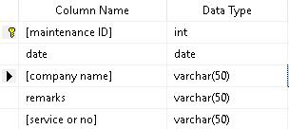

Table Name: Room Maintenance

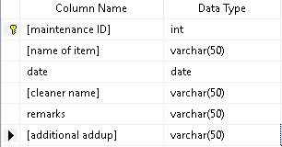

Table Name: Estate Maintenance

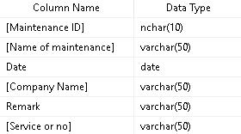

**2.5.3 Report module**

**Simplified Data Dictionary**

Table Name: Room Status

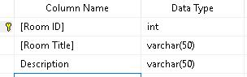

Table Name: All Room listing

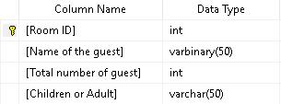

Table Name: All Guest listing

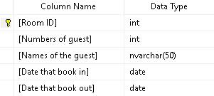

Table Name: Room Status

***Sample data***

|  |  |  |
| --- | --- | --- |
| *Room ID* | *Room Title* | *Description* |
| *0001* | *Deluxe* | *Occupy* |
| *0002* | *Basic* | *Available* |
| *0003* | *Basic* | *Scheduled for cleaning* |

Table Name: All Room listing

***Sample data***

|  |  |  |  |
| --- | --- | --- | --- |
| *Room ID* | *Name of the guest* | *Total number of guest* | *Children or Adult* |
| *0001* | *Haziq* | *2* | *Adult* |
| *0002* | *Achik* | *1* | *Adult* |
| *0003* | *Asyraaf* | *3* | *Adult* |

Table Name: All Guest listing

***Sample data***

|  |  |  |  |  |
| --- | --- | --- | --- | --- |
| *Room ID* | *Numbers of guest* | *Names of guest* | *Date that book in* | *Date that book out* |
| *0001* | *2* | *Haziq* | *01/02/18* | *02/02/18* |
| *0002* | *1* | *Achik* | *01/0/2/18* | *07/02/18* |
| *0003* | *3* | *Asyraaf* | *01/02/18* | *05/02/18* |

**2.5.4 User account login and signup**

Users Signup Table

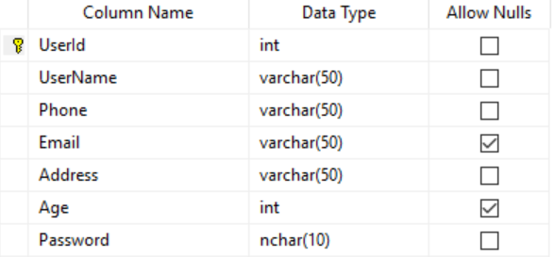

Users Login Table

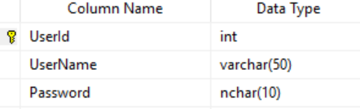

Users and Rooms Table

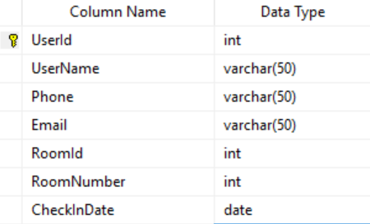

## **2.6 User Interface Requirements**

**2.6.1** Room availability and Booking Pages:

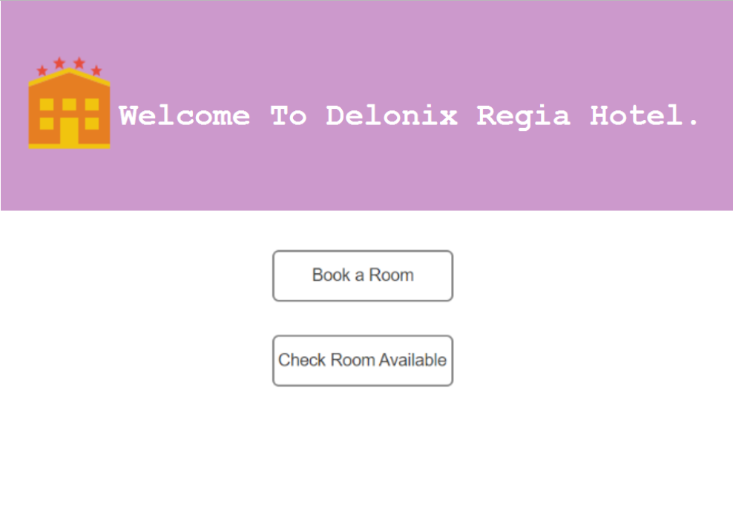

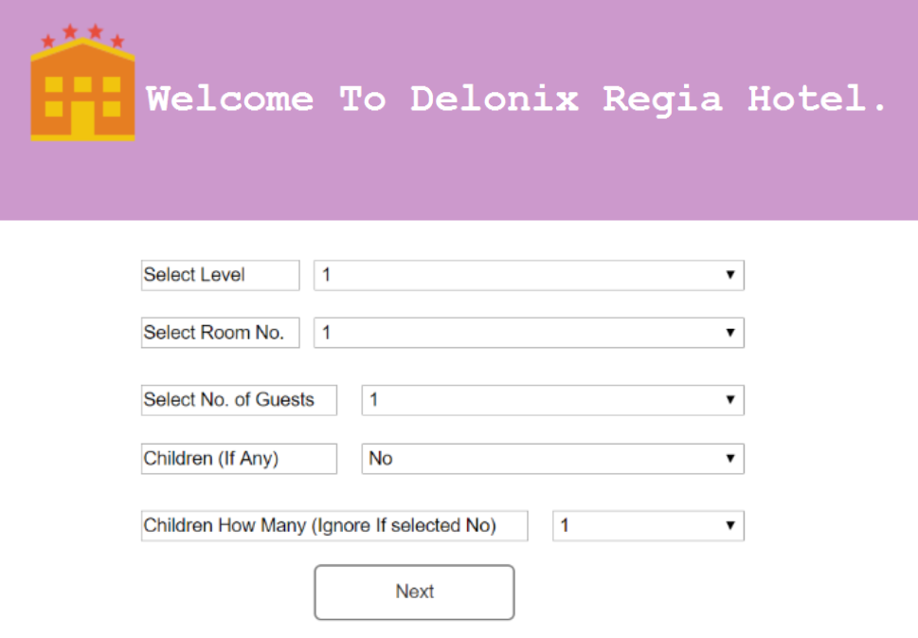

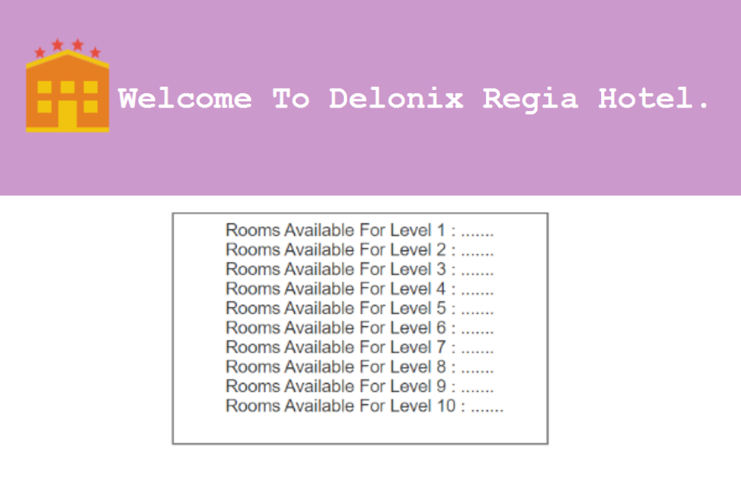

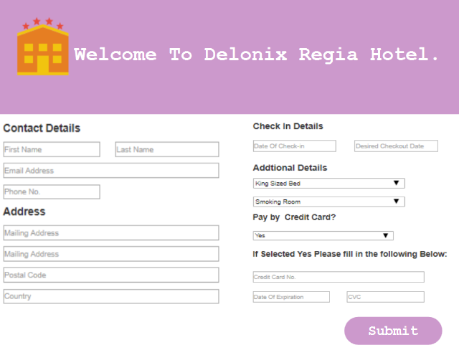

**2.6.2 Staff management modules pages:**

**2.6.3 Report module Pages:**

Image 1 - Home Page

Image 2 - Room Status Page

Image 3 - Room Listing Page

Image 4 - All Guest listing Page

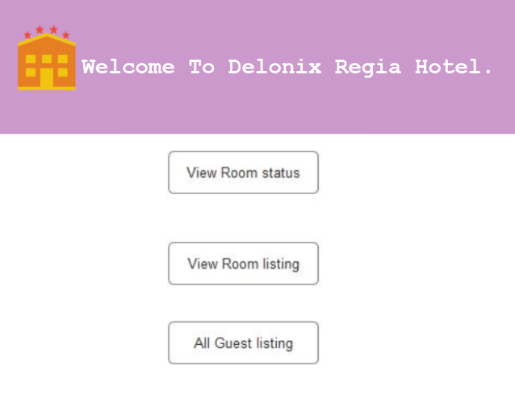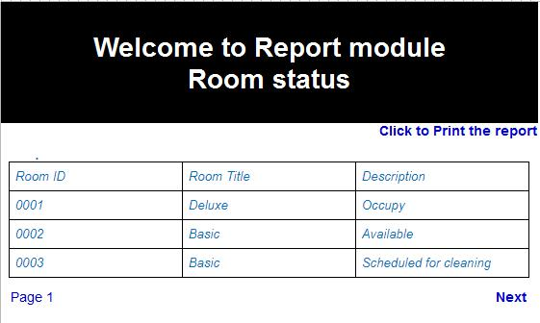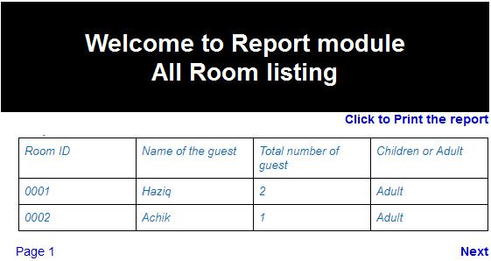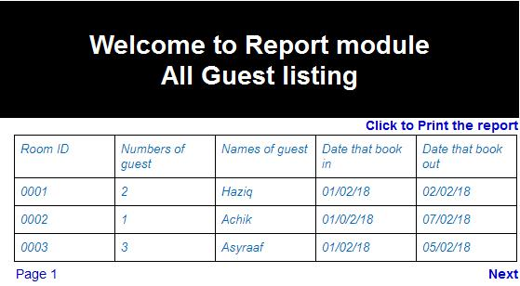

**2.6.4 User account login and signup pages**

Signup Page

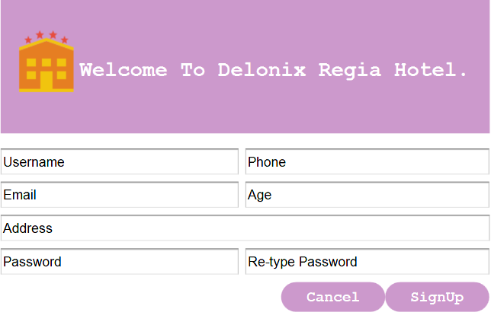

Login Page

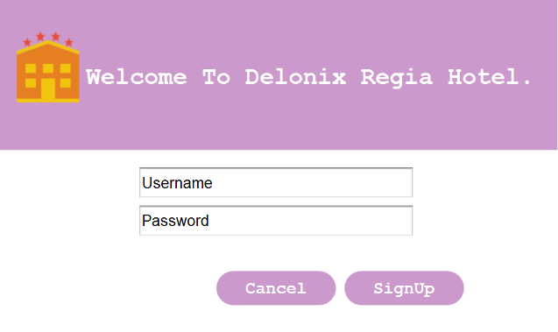

Users Room Page

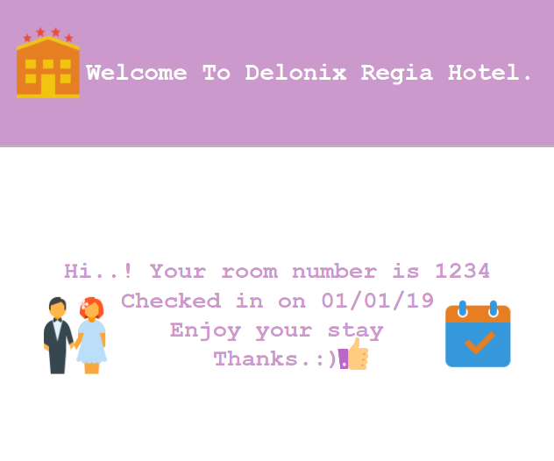

## **2.7 Assumptions**

Based on Owner Wong,

- Software no need to be integrated with others software

- long term are not in priority until the requirements are met.

Report module does not need any edit if mistake in first module room availability and booking. Thus if need any editing, instead of viewing only it can be edited by the administrator if needed.

# 

# 

# **3 REFERENCES**

*Website that are used for referenced are;*

1. [*https://work.chron.com/hotel-maintenance-duties-16024.html*](https://work.chron.com/hotel-maintenance-duties-16024.html)
2. [*https://www.slideshare.net/Snowdaddy73/guest-room-preventative-maintenance-checklist*](https://www.slideshare.net/Snowdaddy73/guest-room-preventative-maintenance-checklist)
3. [*http://www.myappconcierge.com/en/app-management-hotel.php*](http://www.myappconcierge.com/en/app-management-hotel.php)
4. [*https://www.omicsonline.org/open-access/hotel-maintenance-management-practices-2169-0286-1000136.php?aid=78487*](https://www.omicsonline.org/open-access/hotel-maintenance-management-practices-2169-0286-1000136.php?aid=78487)
5. [*https://www.lucidchart.com/*](https://www.lucidchart.com/)

*Software that are used;*

1. *Axure RP 8*
2. *Microsoft SQL Server Management Studio*

Temasek Polytechnic

School of Informatics and IT

**Diploma in Information Technology (IT)**

Software Design Specifications (SDS)

**Project Particulars**

|  |  |
| --- | --- |
| **Tutor** | Mr Qi Yutao |
| **Class** | P04 |
| **Project Title** | Hotel Management System |

**Project Team’s Particulars**

|  |  |
| --- | --- |
| **Matric Number** | **Student Name** |
| **1701635C** | **Frederick Kang** |
| **1705035B** | **Pradhun Raj** |
| **1704762B** | **Haziq Asyraaf** |
| **1705922A** | **Max Ang Chong Wei** |

Revision History

|  |  |  |  |
| --- | --- | --- | --- |
| **Date** | **Version** | **Description** | **Author** |
| 01/12/18 | 0.1 | Fill in the details, update on filling in | ALL |
| 15/12/18 | 0.2 | Update on requirements and constraints etc. | ALL |
| 3/1/19 | 1.0 | Check with the information on meetup | ALL |
| 4/1/19 | 1.2 | Final check on everything | Haziq |

**Table of Contents**

[**1.** **DISTRIBUTION OF WORKLOAD 4**](https://docs.google.com/document/d/1hK3ccUZo1oGj0EsTYVIA8ytwNUMhv23U3F-ed0Mp4tw/edit#heading=h.gjdgxs)

[**2.** **ARCHITECTURE DESIGN 4**](https://docs.google.com/document/d/1hK3ccUZo1oGj0EsTYVIA8ytwNUMhv23U3F-ed0Mp4tw/edit#heading=h.30j0zll)

[**3.** **USER INTERFACE (UI) DESIGN 4**](https://docs.google.com/document/d/1hK3ccUZo1oGj0EsTYVIA8ytwNUMhv23U3F-ed0Mp4tw/edit#heading=h.1fob9te)

[**4.** **PROGRAM DESIGN 4**](https://docs.google.com/document/d/1hK3ccUZo1oGj0EsTYVIA8ytwNUMhv23U3F-ed0Mp4tw/edit#heading=h.3znysh7)

[**5.** **DATABASE DESIGN 4**](https://docs.google.com/document/d/1hK3ccUZo1oGj0EsTYVIA8ytwNUMhv23U3F-ed0Mp4tw/edit#heading=h.2et92p0)

# **1. DISTRIBUTION OF WORKLOAD**

# 

*[Determine which members of the team will be responsible for which areas of design. Individual’s responsibilities should be clearly spelt out.]*

|  |  |
| --- | --- |
| **Design** | **Members** |
| 2 Architecture  3.2 Room availability and booking pages  5.2 Room availability and booking pages | Frederick Kang |
| TOC:Table of Content  3.1 User Interface Design  3.4 Report module pages  5.1 Database Design  5.4 Report module | Haziq |
| 3.3 Staff management pages  5.3 Staff management | Max |
| 3.5 User account login and signup pages  4 Program Design  5.5 Signup and Login Module Tables | Raj |

# 

# **2. ARCHITECTURE DESIGN**

# A three-tier architecture is a client-server architecture in which the functional process logic, data access, computer data storage and user interface are developed and maintained as independent modules on separate platforms. Three-tier architecture is a software design pattern and a well-established software architecture.

Three-tier architecture allows any one of the three tiers to be upgraded or replaced independently. The user interface is implemented on a desktop PC and uses a standard graphical user interface with different modules running on the application server. The relational database management system on the database server contains the computer data storage logic. The middle tiers are usually multitiered.

The three tiers in a three-tier architecture are:

1. Presentation Tier: Occupies the top level and displays information related to services available on a website. This tier communicates with other tiers by sending results to the browser and other tiers in the network.
2. Application Tier: Also called the middle tier, logic tier, business logic or logic tier, this tier is pulled from the presentation tier. It controls application functionality by performing detailed processing.
3. Data Tier: Houses database servers where information is stored and retrieved. Data in this tier is kept independent of application servers or business logic.

But in this case here, we be using angular-apps to code out the pages for the web application, we will use MongoDB for the database, and we are using NodeJs as well.

# 

# 

# 

# 

# **3. USER INTERFACE (UI) DESIGN**

**3.1 User Interface (UI) Design**

*This design is made by axure RP 8 software, this UI is simple and easy to train under short schedule or uptight schedule. Therefore if the there is some delay in implementing the system we can use this UI to cut short in the time. This UI usability will affect the user that is working to be use in efficient in cutting time, because it is the main focus to not heavyload the software instead make it bugs-free. By adapting this UI controls, we can easily make changes in the system database. This is low-fi products that we had made using axure RP 8, as its low-fi the colours,ui design, and perhaps even font can be change and design better in high-fi. This is the required UI needed for our system software. We assumed that these are the requested for these function and we only deliver it without any much changes. Therefore we can only change based on the graphics. This UI does not have any constraint as it’s easy to deliver if its based on low-fi, it can just run perfectly on normal internet explorer just using page to load up the HTML page.*

# **3.2 Room availability and Booking Pages.**









**3.3 Staff management Pages:**

**3.4 Report module Pages:**

Image 1 - Home Page

Image 2 - Room Status Page

Image 3 - Room Listing Page

Image 4 - All Guest listing Page



**3.5 User account login and signup pages**

Signup Page



Login Page



Users Room Page



# 

# 

# 

# 

# 

# 

# **4. PROGRAM DESIGN**

Use Case Diagram

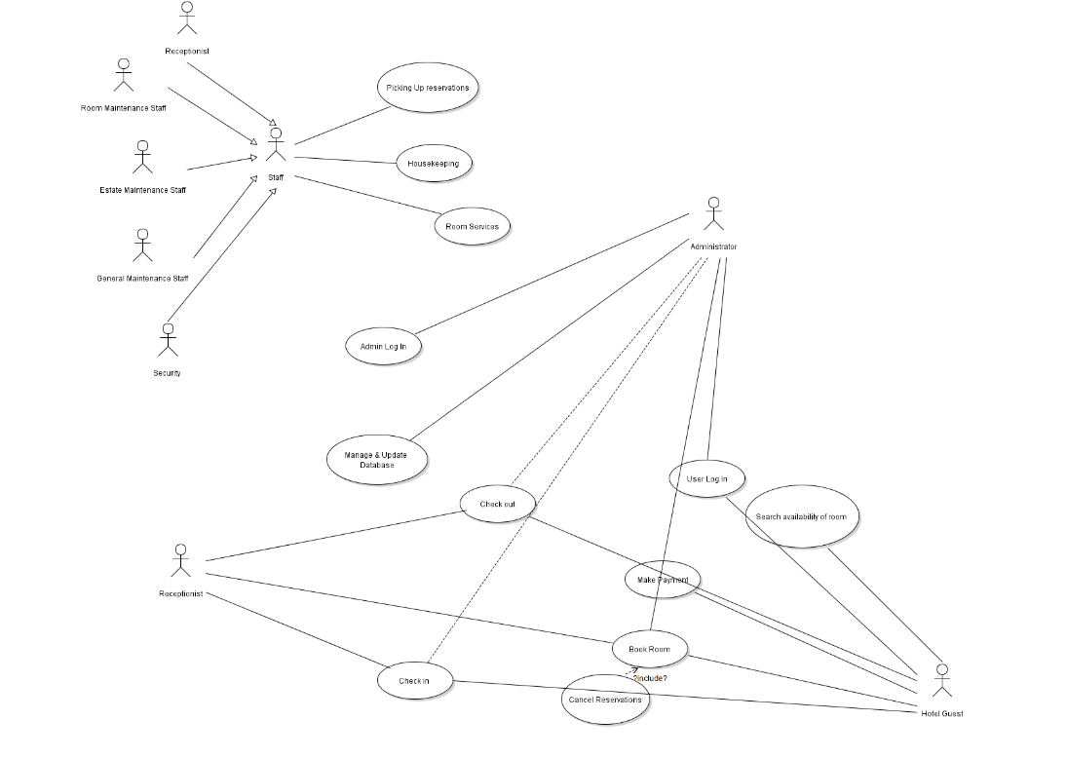

# 

# 

# 

# 

# **5. DATABASE DESIGN**

*5.1*

*When designing the database , the database are to make full use efficiently based on what the owner needs. There is no extra things, and we make the names and size capacity as small and efficient. This takes into an account of the simplicity of the data storage with limitations. Due to this there isn’t any need to add any extra. This takes account of all the database that takes place in every module.*

**5.2 Room availability and Booking**

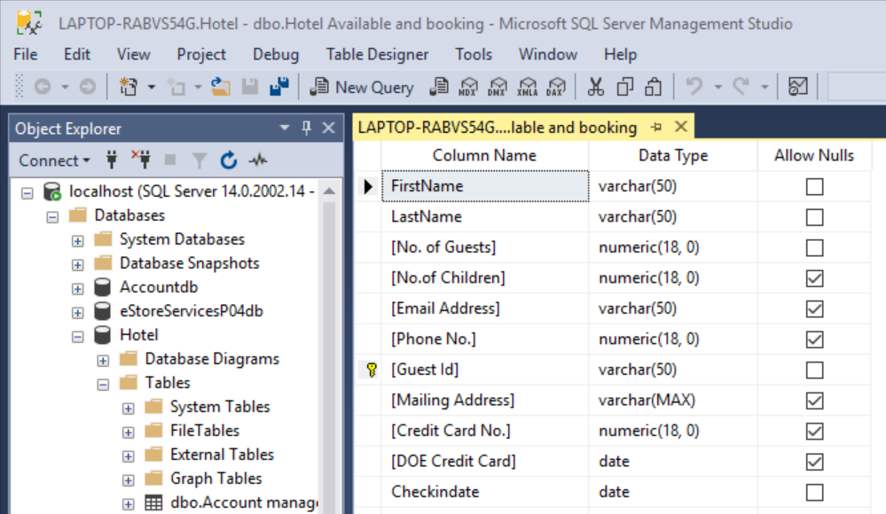

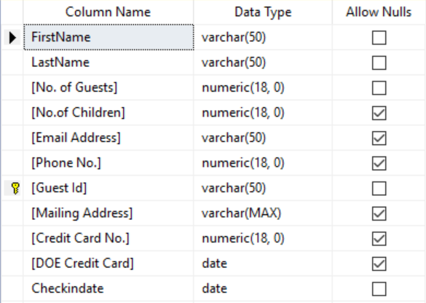

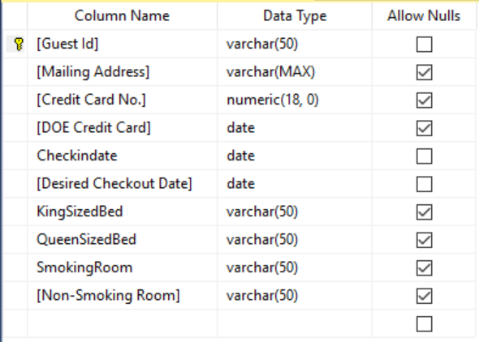

**5.3 Staff management**

Table Name: General Maintenance

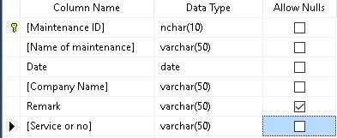

Table Name: Room Maintenance

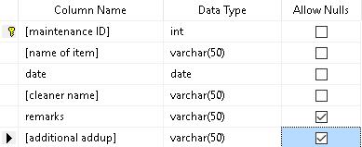

Table Name: Estate Maintenance

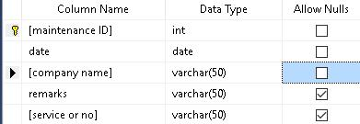

**5.4 Report module**

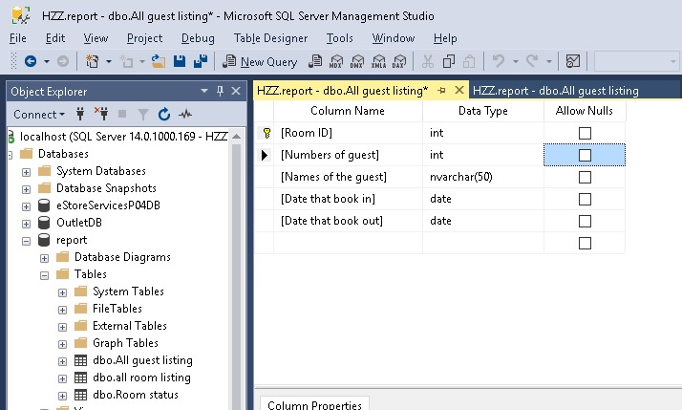

Table Name: Room Status

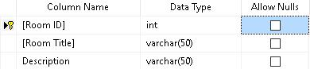

Table Name: All Room listing

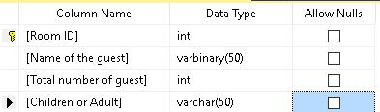

Table Name: All Guest listing

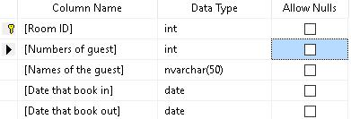

Database Schema:

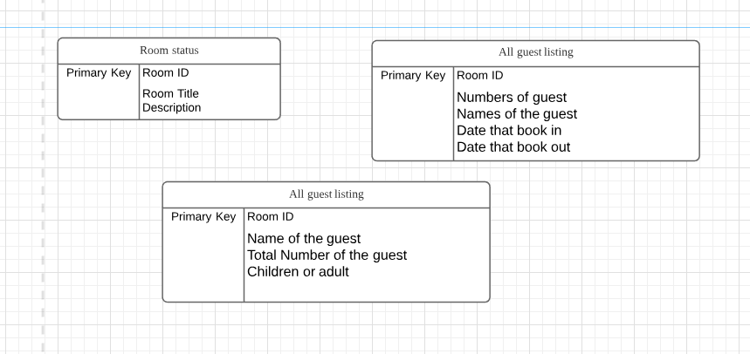

**5.5 Signup and Login Module Tables**

Users Signup Table



Users Login Table



Users and Rooms Table

